Excelerate Multi Asset Income Fund
卓思多元资产收益基金
This summary provides you with important information about this product
This summary is part of the sales document
You should not invest in this product solely based on this summary
Fact Sheet
Management Company | Excelerate Fund Management Limited
基金要素 | 卓思基金管理有限公司
Management Fees | 1% per annum, calculated based on the fund's net asset value (NAV)
Performance Fees (after deducting management fees) | Annual fund NAV growth rate | If the return is greater than 5.55%, 10% of the total return will be withdrawn；
Performance Fees (after deducting management fees) | Annual fund NAV growth rate | If the percentage is between 5% and 5.55%, extract 100% of the portion exceeding 5%.
Subscription amount | First Subscription | Starting from HKD 3 million, or equivalent foreign currency
Subscription amount | Additional Subscription | Starting from HKD 1 million, or equivalent foreign currency
Subscription Fees | Maximum 1.5% (collected upfront)
Subscription Period | Applications will be closed 10 business days before the last trading day of each month, after 5:00 p.m.
Lock-Up Period | 1 year
Redemption Fees | Redemption fees waived after the lock-up period
Redemption Conditions | The pricing date is the last trading day of each quarter (March, June, September, and December), and the redemption date is the first trading day of each quarter. Clients must submit their applications 15 business days prior to the redemption date. Large redemptions are subject to special terms in the fund contract. For detailed redemption rules, please refer to page 8 of the supplementary document to the private placement memorandum for detailed guidance on redemptions.
Asset Under Management (AUM) | USD 9.4M (As of 31 March 2026)
Base Currency | USD
Fund Director | Choi Cheuk Heng Zenith, Ho Wai Keung Terrence
Portfolio Managers | Choi Cheuk Heng Zenith, Yang Yunshan Vincent
Custodian | Bank of Communications Trust Co., Ltd.
Agency | CLSA Limited
What kind of product is this fund?
Excelerate Multi Asset Income Fund ("the Fund") is an open-ended fund，This fund was officially launched in November 2024. This fund is incorporated under the Securities and Futures Ordinance (Chapter 571) of the Hong Kong Special Administrative Region and operates as an Open-Ended Fund Company (OFC). The operation and management of the fund comply with the relevant regulations and guidelines of the Hong Kong Monetary Authority and the Securities and Futures Commission.
This fund has been included in the list of qualified collective investment schemes under the New Capital Investor Entrant Scheme (New CIES).
Objectives and Investment Strategies
This fund primarily invests in a collective investment scheme centered on structured products such as Hong Kong and US-listed index-linked ETFs, stocks, and high-yield notes linked to indices and stocks. Approximately 80% of the fund's investment is in high-yield notes, with the remaining 20% ​​optionally held in notes, stocks, ETFs, or cash.
Diversification is a core strategy of this fund. By selecting stocks concentrated in or within an index, based on indices, the fund effectively reduces the volatility of its asset prices and provides significant resilience during financial crises. This fund focuses on long-term, stable returns, generating returns comparable to or even better than equity funds both during periods of asset decline and under normal circumstances. Therefore, this fund is particularly suitable as an investment vehicle for investment immigration programs lasting up to 7 years.
Under normal circumstances, this fund will not use leverage to enhance returns. Please refer to page 4 of the supplementary private placement memorandum for details regarding leverage.
Use of Derivatives / Investment in Derivatives
This fund is a derivative product. It carries the characteristics and risks of derivatives. Investors should have a basic understanding of derivatives. If you have any questions about this fund or derivatives, you should consult a third-party investment advisor for investment advice.
What Are the Main Risks of This Fund?
- Investment Risk: This fund is an investment fund. The value of the fund's portfolio may decline due to any of the following risk factors, and your investment in this fund may incur losses. There is no guarantee that the principal will be returned. The performance of this fund depends in part on the success of the asset allocation strategy employed. There is no guarantee that the strategy employed by this fund will be successful, and therefore the investment objectives of this fund may not be achieved.
- Capital Growth Risk: Risks associated with income-generating investment strategies This fund employs an income-generating investment strategy, which may reduce the fund's capital growth potential and future income.
- Credit Risk: Issuer and counterparty risk – Bankruptcy, default, credit rating downgrade, or sanctions due to geopolitical factors may lead to losses for this fund. It also raises liquidity risk.
- Currency Risk: This fund may invest in assets denominated in currencies other than the fund's base currency (primarily US dollars and Hong Kong dollars). Furthermore, the designated currency for certain share classes may be a currency other than the fund's base currency.
- Interest Rate Risk: Rising interest rates may adversely affect the assets held by the Fund.
- Non-Investment Grade/Unrated Bond Risk: The high-yield bonds invested in by the Fund generally lack credit ratings. They are also subject to short-term price fluctuations due to the issuer's credit rating. Therefore, liquidity in the secondary market is relatively low.
- Derivative Instrument Risk: Risks associated with derivative instruments include counterparty/credit risk, liquidity risk, valuation risk, the risk of irrational short-term volatility, and over-the-counter trading risk. In adverse circumstances, the Fund may incur additional losses due to hedging of its portfolio.
- Liquidity Risk: The size and trading volume of the securities markets associated with the Fund may be significantly smaller than those in developed markets. This may lead to reduced liquidity and difficulty in selling such securities, potentially reducing the Fund's returns/causing losses for investors.
Does This Fund Guarantee the Principal?
This fund is not a principal-protected fund.
Comments section | Key Messages
Market Review | The first quarter of 2026 opened constructively but grew increasingly turbulent as geopolitical shocks, persistent inflation, and a rotation away from growth stocks left most major indices in negative territory by quarter-end.  U.S. equity markets began 2026 on a positive note, with broad participation and leadership from value-oriented segments, reversing the prior year's mega-cap tech dominance. The mood soured quickly, however. The onset of conflict with Iran in late February sent oil prices surging and injected a new level of uncertainty into global financial markets. The U.S. market ended Q1 down approximately 4%, with a particularly painful March declining nearly 5%. Inflation re-accelerated sharply to 3.3% by March, while a new 10% global trade surcharge kept the average U.S. tariff rate near decade highs, adding pressure on manufacturers and consumers alike.  China entered the quarter with solid footing following its 2025 growth target being met and a late-2025 trade truce with Washington. Respondents in Greater China remained among the most globally optimistic on economic conditions, though deflationary pressures and property sector weakness persisted as structural concerns.  Hong Kong presented a contradictory picture. Trading was highly active with average daily turnover surpassing HKD 200 billion throughout the quarter, yet this liquidity did not translate into broad index gains. External headwinds dragged the Hang Seng into a modest correction, ending the quarter down roughly 2 to 3%. The IPO market remained a bright spot, and Hong Kong's role as a fundraising hub for Chinese firms continued to strengthen as mainland companies shifted away from U.S. listings.  Overall, the quarter was defined by geopolitical repricing, inflationary surprises, and a clear investor preference for defensiveness over growth across all three markets.
Performance | +0.73% since issuance (see Figure 1).
Investment Strategies and Allocation | The portfolio's orientation toward capital preservation during Q1 was well-founded and is supported by the data. With the U.S. market declining roughly 4% over the quarter and inflation re-accelerating to 3.3% by March, deploying aggressively into equities would have been premature. Holding a substantial cash buffer preserves optionality at a time when monetary policy direction remains uncertain and the Federal Reserve finds itself constrained by competing pressures on both growth and prices.  The selective allocation to Technology reflects a considered, long-term conviction rather than a chase for near-term momentum. Consensus expectations point to Big Tech earnings growth of roughly 22% in 2026 and 2027, continuing to outpace the broader market. Morgan Stanley estimates that nearly $3 trillion of AI-related infrastructure investment will flow through the global economy by 2028, with more than 80% of that spending still ahead. The Q1 pullback in tech names arguably makes current entry points more attractive on a forward basis. The Consumer Cyclical allocation is equally grounded in evidence: retail and food services sales rose 0.6% in February and were up 3.7% year on year, signaling ongoing expansion in household demand. For Q1 2026, the LSEG Retail and Restaurant Index is tracking a 6.1% blended estimated revenue growth rate, with six out of ten consumer-related industries turning positive. This is not a momentum trade. It is a recognition that the consumer, while more selective, has not broken.
Outlook | The case for a cautiously constructive posture into the second half of 2026 rests on several converging data points, even if near-term risks remain elevated.  On the consumer front, the resilience observed in Q1 is more durable than sentiment headlines suggest. U.S. retail sales climbed 1.7% month on month in March 2026, the steepest rise since March 2025, with core retail sales rising 0.7% and beating forecasts of 0.2%, driven by broad-based gains across motor vehicles, electronics, furniture, and general merchandise. Tax cut legislation passed last year is projected to translate into an additional $50 billion in individual tax refunds on 2025 returns, providing a meaningful offset to higher energy costs. This suggests that even with elevated oil prices, disposable income support could sustain consumer activity through at least mid-year, reinforcing the rationale for retaining Consumer Cyclical exposure.  The Technology sector remains the most compelling structural story, despite its difficult Q1. The valuation reset that accompanied the broader market selloff has, if anything, improved the risk to reward profile. Information Technology and Communication Services are projected to lead S&P 500 revenue growth in 2026, and the estimated net profit margin for the S&P 500 stands at 13.9%, well above the 10-year average of 11.0%. Critically, AI adoption is shifting from pilot programs toward tangible productivity solutions, with AI adopters seeing cash flow margin expansion outpacing the global average by a factor of two. This is no longer speculative narrative; it is beginning to show up in earnings.  The geopolitical risk environment, while still elevated, may be approaching a turning point. The Iran conflict triggered the most acute phase of Q1 volatility, but energy markets tend to price in conflict premiums swiftly, and any de-escalation could release meaningful pent-up demand for risk assets. On the monetary policy front, markets continue to price in two Fed rate cuts in 2026, which if delivered in the second half would ease financial conditions and provide a supportive tailwind for both equities and credit.  China's Q1 GDP beat of 5% against a consensus of 4.8% is an encouraging data point that should not be overlooked. It suggests that Beijing's measured approach to stimulus is working at the margins, and that the deflationary spiral feared by many has not materialised. Hong Kong's robust IPO pipeline and deepening role as a capital markets hub add a structural layer of support to the broader Greater China investment thesis.  The overall posture entering Q2 is one of patience with a constructive bias. Cash remains the anchor, protecting capital while preserving the flexibility to deploy into Technology and Consumer Cyclical names as volatility subsides. The building blocks for a stronger second half are credible, and the Q1 drawdown has, in several respects, created a more attractive entry point than existed at the start of the year.

Figure 1. Performance of Excelerate Multi Asset Income Fund
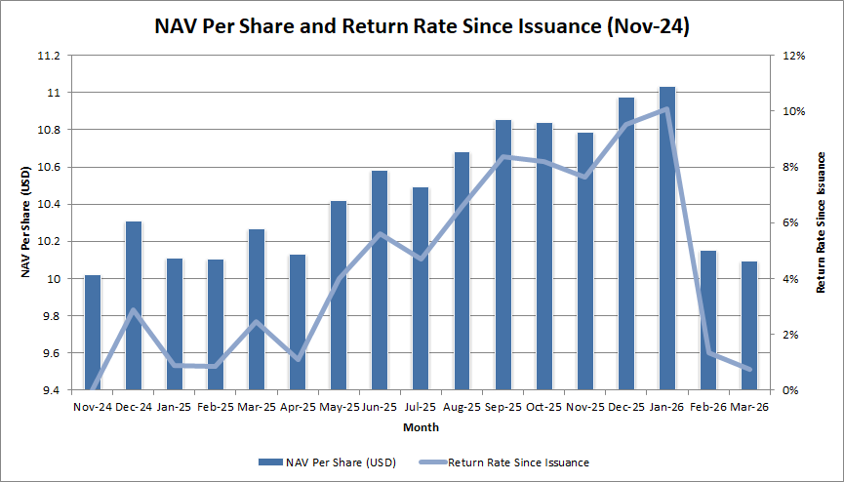
*The Excelerate Multi Asset Income Fund was officially issued in November 2024
Figure 2. Portfolio distribution as of March 31, 2026
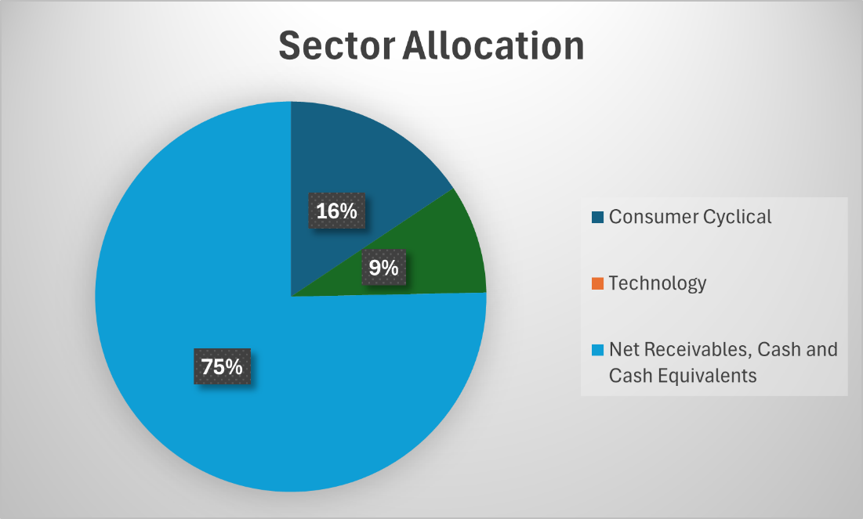
Data Source: Excelerate Fund Management Limited
Update Frequency: Quarterly
Report Date: 1 April 2026
Legal Disclaimer and Notice
This Fund (“Excelerate Multi Asset Income Fund”) is incorporated under the Securities and Futures Ordinance (Chapter 571) of the Hong Kong Special Administrative Region and operates as an Open-Ended Fund Company (OFC). The operation and management of the Fund comply with the relevant regulations and guidelines of the Hong Kong Monetary Authority and the Securities and Futures Commission. Investors should carefully read the disclaimer before investing in this Fund and seek independent professional advice if in doubt. This Fund is only open to professional investors who meet the requirements of the Hong Kong Securities and Futures Ordinance.

Open-ended funds are products with continuous subscription and redemption. Subscriptions and redemptions are allowed daily. In the event of massive redemptions, the manager may postpone payments or suspend redemptions and protect the interests of holders through valuation adjustments and other means. (Investors should carefully read the fund contract, prospectus, and other legal documents to understand the fund's risk and return characteristics and determine whether the fund is suitable for their risk tolerance based on their investment objectives, investment horizon, investment experience, and assets.)
https://www.sfc.hk/en/Regulatory-functions/Products/List-of-Eligible-Collective-Investment-Schemes-under-new-CIES

